Ben Lincoln: Immersions 2019

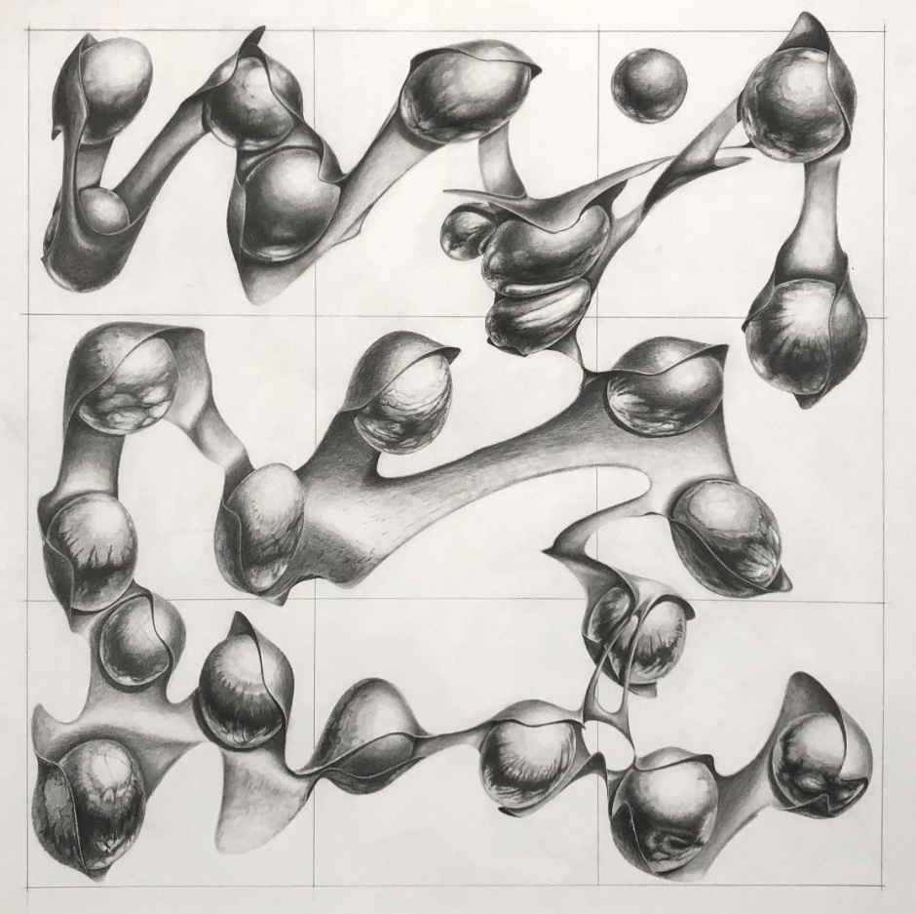
“This is Just to Say”, graphite on paper
“Electromagnetic technology requires utter human docility and quiescence of meditation such as befits an organism that now wears its brain outside its skull and its nerves outside its hide. Man must serve his electric technology with the same servo-mechanistic fidelity with which he served his coracle, his canoe, his typography and all other extensions of his physical organs. But there is a difference, that previous technologies were partial and fragmentary, and the electric is total and inclusive.
-Marshall McLuhan

The quote above is from Marshall McLuhan’s 1964 book Understanding Media. Central to his thesis is that the essential function of any technology is to extend some capacity of the human body or mind - the car for example extends the feet and legs, allowing us to travel farther and faster. In the book McLuhan proposed that the mass media of his day, and to an even greater extend the digital media of ours, extends the brain and central nervous system outside the body. In my last newsletter I showed you a still life, this time around I’m presenting a drawing and I’ll zoom out a bit here to bring the larger project I am working on into view. In August of this year I’ll be presenting a body of new work in a solo exhibition at the Littlefield Gallery titled “Interface” in which I’ll be considering the effects of this extension of mind and how I visualize that in my art.

I think one of the single biggest features of this extension is a change in the relationship between the internality of the self and the externality of the objective world. I’m not a sociologist or neurologist, but it seems apparent to me that some of the deepest internal processes of mind are now manifesting externally. To illustrate my point, the next time you decide to get a candy bar when you’re in the checkout aisle of the grocery store consider what is happening in your brain. Separate neural networks, each corresponding to a different candy bar choice, battle it out in a high stakes winner take all contest for survival. Not only do these networks compete head to head, suppressor neurons in each camp actively try to undermine and sabotage the competition. It’s a hot, fast paced game involving a kind of neural hyperbole, fake news, and disinformation… sounds a lot like a political campaign on social media. It’s not that these kinds of social phenomena are new, they’re not, it’s the speed and totality with which they manifest today that is qualitatively different.
Thinking about this idea of internality has led me to a somewhat different approach to my own work as well. For most of my career I have tended to to take inspiration from external sources and then created my own imaginative twists on those themes. Now though, I am looking inward to the relationship I have to form and shape that is always present in my work no matter the subject matter I am working with.

"Sometimes a shape will say only that it is round, or flat, squiggly or straight, shiny or matt - and I am satisfied with that. After many years I can finally say that I don't need a shape to relate to something external."

With that I’ll turn back the clock about twenty years or so to the beginning of my career when my relationship with form began to take shape. Throughout college and the early part of my career I developed what I thought of as a somewhat peculiar language of shapes and organized my work around different scientific concepts. Anatomy, genetics, physics and chance operations all inspired me at various times:

Throughout this period though a troubling question persisted in the back of my mind that finally broke into a full blown confrontation; strip all the external ideas away and what do my shapes mean, what if I just painted them on their own? I made numerous attempts, but trying to paint my “shape language” without an external source of meaning invariably led me to the edge of cliff with giant frightening nothingness beyond… so I continued to organize myself around external ideas.

A couple of years ago though an urge to work with my shape language on its own terms again began to build in me. At about this time I also re-acquainted myself with the experimental composer John Cage, I had first listened to his work in the late nineties when I was making a series of aerator drawings using coin tosses to determine the orientation and relationships between the various elements in the compositions:

Cage had made extensive the use of chance operations in his musical compositions for many years, and when I renewed my interest in his work I came across an interview he gave shortly before his death in the early nineties:

“When I hear what we call music, it seems to me that someone is talking; about his feelings, or about his ideas of relationships. But when I hear the sound of traffic, here on sixth avenue for instance, I don’t have the feeling that someone is talking. I have the feeling that a sound is acting, and I love the activity of sound. What it does is it gets louder and quieter, and it gets higher and lower, and it gets longer and shorter. It does all those things which I’m completely satisfied with, I don’t need sound to talk to me.”

Finally, I have come to realize that I feel the same way about my shape language. Sometimes it will manifest itself in forms that relate to the external world, a still life for instance… but not always. Sometimes a shape will say only that it is round, or flat, squiggly or straight, shiny or matt - and I am satisfied with that. After many years I can finally say that I don't need a shape to relate to something external, what I am most interested in at this time is my internal experience of form.

In my studio practice I have long been aware of a relation between the movements of drawing and painting and my visual sensibility of the shapes produced. I find that certain movements of my hand and ways of manipulating pencil or brush have a feeling of correctness to them, almost invariably this sensation of movement corresponds to a shape or painterly effect that I find visually appealing. The experience feels a bit like a kind of internal dialogue is taking place between conscious and non-conscious parts of my brain, but I want to draw a distinction here between my practice and the automatic drawing of the early 20th century surrealists.

Artists like Andre Masson in this drawing attempted to suppress the conscious mind in order to allow the unconscious to assume control. To accomplish this, they often sought to achieve a trance like state as they worked.

For me it’s different, I’m not so much trying to suppress the conscious mind as stand beside it, I think of it as more meditation than trance. I find that drawing or painting beside myself in this way engages a different kind of observation, one that allows a glimpse of the interior.

I think of “This is Just to Say” as a kind of poem - I actually borrowed the title from one of my favorite poems by William Carlos Williams. If my drawing is a poem, it’s a poem without meaning. For a long time I was afraid of the meaningless emptiness this work brings me to, but now I think bringing me to that void is its purpose. I think the only way to reach “inner” language is to give up the meaning of “outer” language.

I’ll close with a quote from Zen Buddhist master Shunryo Susuki,

“Usually we think of our mind as receiving impressions and experiences from outside, but that is not a true understanding of our mind. The true understanding is that the mind includes everything; when you think that something comes from outside it means only that something appears in your mind.”

