AMY POLLIEN
Heron with Marigolds and Mussels
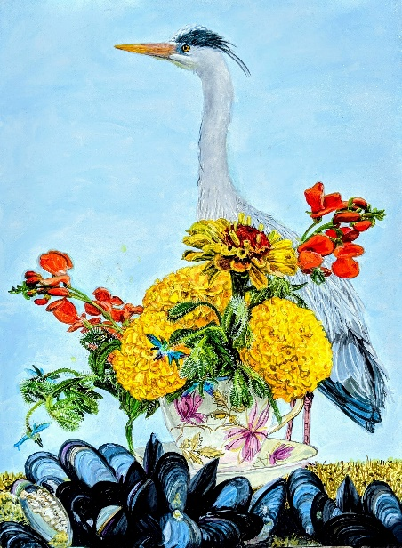

Heron with Marigolds and Mussels

We live in the village of Town Hill, in the center of Mount Desert Island at the head of Somes Sound. Just across our gravel road there’s a path down a steep embankment to the very beginning of Somes Sound that hosts an incredible variety of wildlife. Blueberries, sargent-berry, and small birch on the upslope give way to reeds interspersed with wool-grass (Scirpus cyperinus) as the ground gets boggy. There are wild cranberries growing on old stumps covered with sphagnum moss and occasional granite outcroppings covered in crawling pine and winterberry that make stepping stones across the streams.

Further down the embankment, closer to the Sound, there are tidal areas of silt and sunken rock covered in mussels. The water is quite still and warm in the summer so we humans don’t harvest there, but the animal and bird populations consider it a 24-hour buffet. Herons are solitary hunters and don’t mind being out in the noon-day sun (which makes them easier to paint) staking out their territory on the ground or flying overhead with their stilt legs extended and necks tucked in. Groups of crows and ravens arrive in the early morning and squabble over snails and carrion in the weeds, but most of the wildlife show up near dusk: raccoons, fox, the local pine marten (or maybe several pine martens that I can’t tell apart), and black bears with cubs. Food is abundant so the mixed group is generally peaceful and only the crows make a lot of noise. At high tide I might see black ducks or Canada geese during the migration. It’s a popular spot with insects of all types but the deer don’t frequent the marsh so I don’t have to be as vigilant about ticks. This is where the painting of the heron, and the raft of mussels, originated - although the documentation is from two separate visits.

I receive a fair number of still life objects from friends and this tea cup is from my friend Meredith. It was her mother’s favorite, and she was also a big fan of my painting, so this is something of a tribute to Margaret Frances McNaught Jones, who passed away in 2010. She was a long-time resident of Eastport and championed many causes there. I wanted to use her piece in the painting with the flowers commonly grown in Downeast gardens: bright yellow marigolds and scarlet runner beans.

